

#### ST. PAUL’S UNIVERSITY

#### Private Bag - 00217 Limuru, Kenya

#### Tel. Office: 020-2020505/10; Mobile: 0728-669000

#### Website: www.spu.ac.ke

**FACULTY OF BUSINESS COMPUTER SCIENCE AND COMMUNICATION STUDIES**

**software engineering**

**{adm no}**

**MACHAKOS CAMPUS**

**COVID-19 APPLICATION DOCUMENTATION AND REPORT**

**INTRODUCTION**

Due to spike in cases of covid 19,the government has sought a way to successfully estimate and know the people who are infected or have come into close contact with infected people, early in advance to help control the spread of the virus. It has decided to use this application to help its covid 19 task force in contact tracing. The application is projected to help relive health workers a lot of work and help flatten the spread curve, thus saving more lives in the process.

**APPLICATION MOCK UPS**

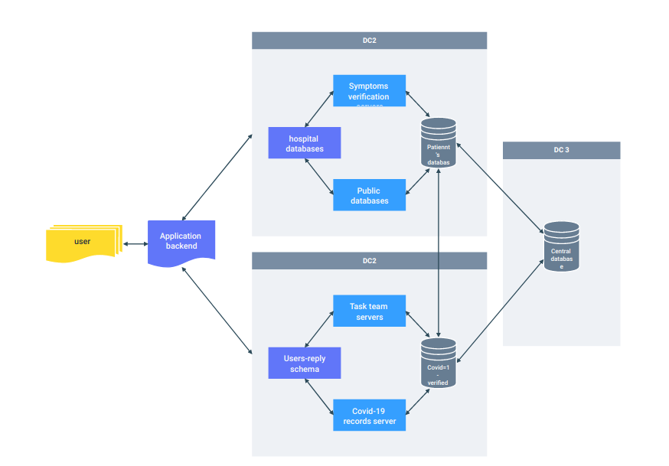

**APPLICATION REQUIREMENTS**

**-**To run the application, you are required to have the following installed in the operating system you are using;

Python 2.6 -3.7

Flask==0.10.1

gunicorn==19.6.0

itsdangerous==0.24

Jinja2==2.8

MarkupSafe==0.23

Werkzeug==0.11.10

code editing tools e.g IDE like pycharm

**HOW TO RUN THE APPLICATION**

Once you have the above requirements ready, open your code editing software eg. Pycharm.

-Import the folder containing the whole application

-navigate to main.py and open it

-run the main.py to start the application

-open a browser window and navigate to the local host server and the port the app is running on.

**TEST PLAN AND RESULTS**

Through use of publicly available data, a test run of the project was done, the results where as intended, the application run smoothly, and was able to do the automated tasks as intended, After several successful test runs the project was green lighted to go live.

**APPLICATION PROS**

-Easy contact tracing

-It is easy to locate anyone as all the information is submitted through the form

-ease of use

-does not require a lot of things to set it up

-runs in a website so it is able to be accessed anywhere and on any device

**APPLICATION CONS**

**-**Sensitive information is shared through the form